**Ideation Phase**

**Brainstorm & Idea Prioritization Template**

|  |  |
| --- | --- |
| Date | 11 October 2022 |
| Team ID | PNT2022TMID12047 |
| Project Name | Car Resale Value Prediction |
| Maximum Marks | 4 Marks |

**Brainstorm & Idea Prioritization Template:**

To collectively come up with a solution to a work problem and ensure that everyone has a say in how it is being solved. Brainstorming can also be effective if you are out of ideas and need to come up with new ones moving forward.

Brainstorming allows people to think more freely, without fear of judgment. Brainstorming encourages open and ongoing collaboration to solve problems and generate innovative ideas. Brainstorming helps teams generate a large number of ideas quickly, which can be refined and merged to create the ideal solution.

**Step-1: Team Gathering, Collaboration and Select the Problem Statement**

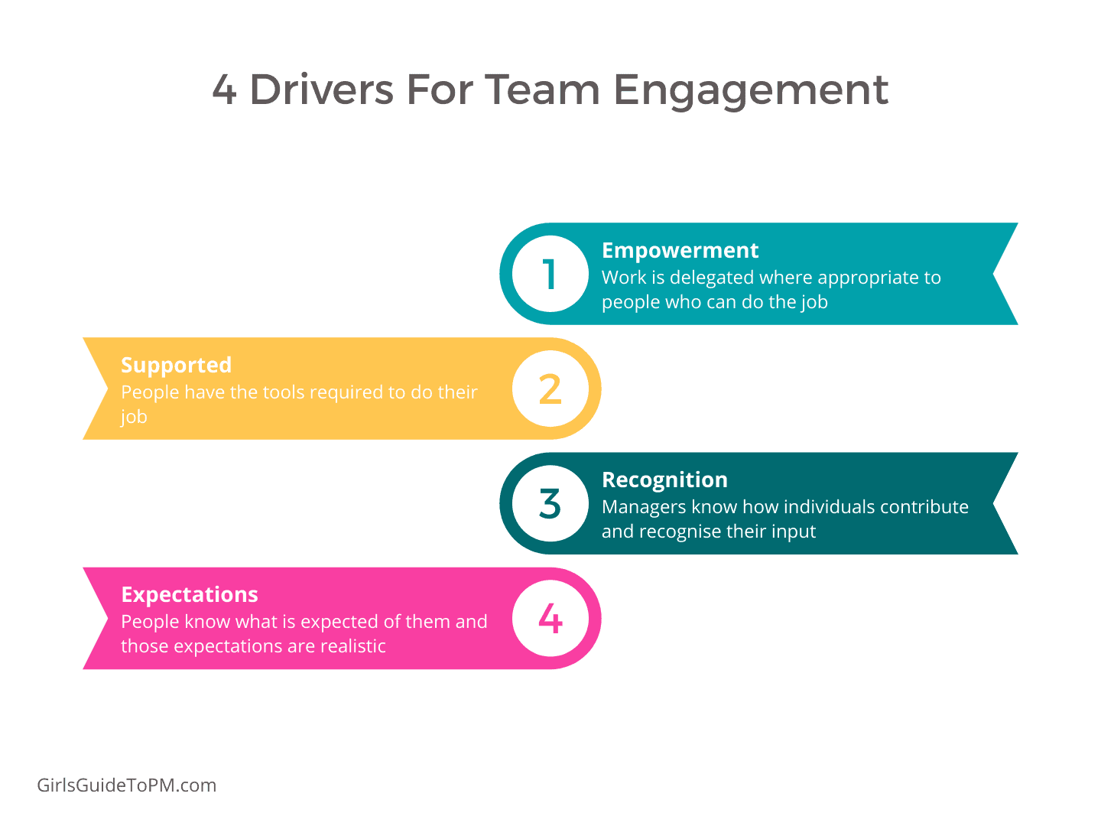

Collaboration

Brings together people with different skills and experience to solve a problem or work on a project

Everyone involved is united behind a common goal and authority is shared

Collaboration takes places in terms however it is distinct way of working

Brainstorm and idea prioritization

Brainstorming allows people to think more freely, without fear of judgment. Brainstorming encourages open and ongoing collaboration to solve problems

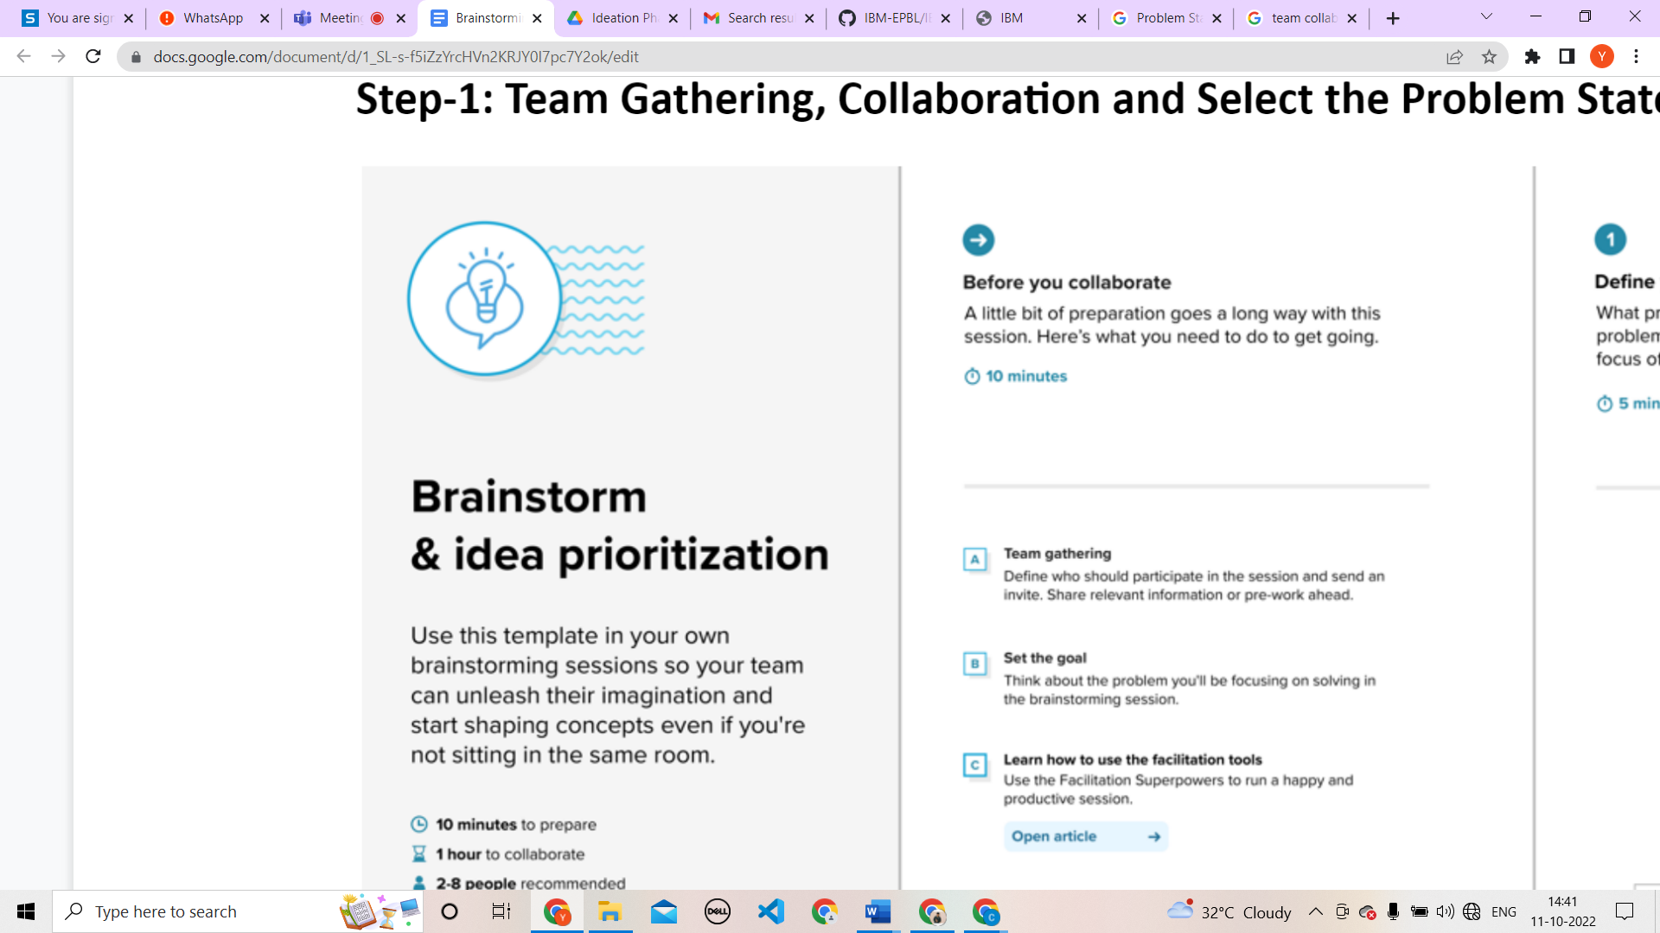





**Step-2: Brainstorm, Idea Listing and Grouping**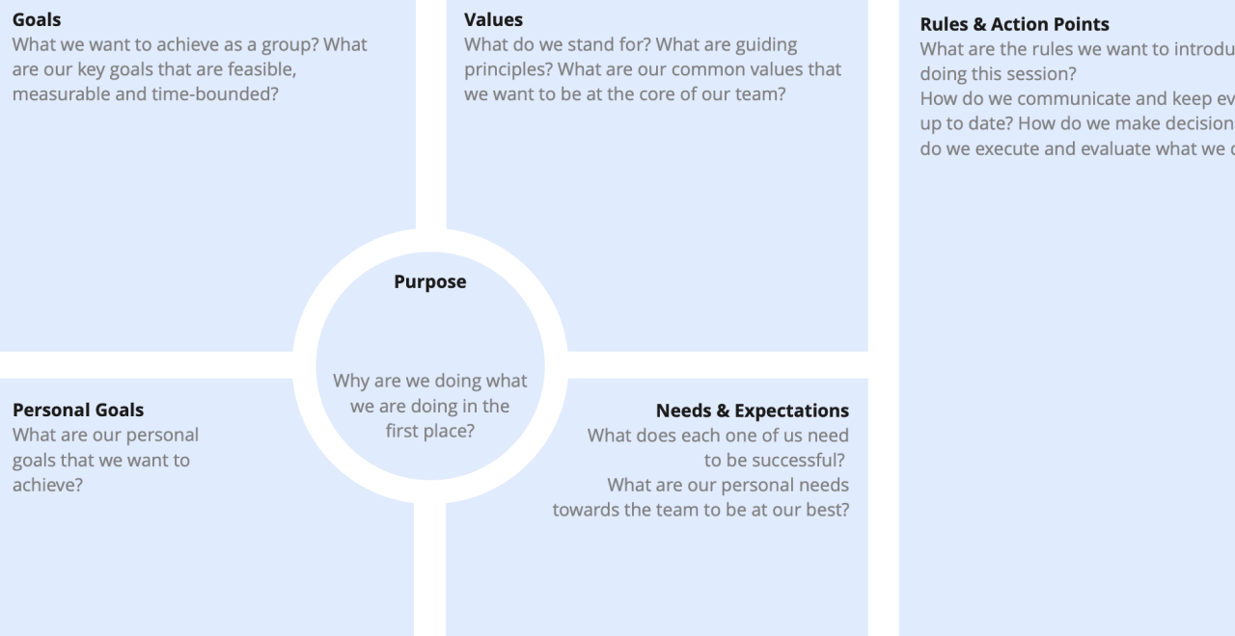

To be able to predict used cars market value can help both buyers and sellers.

**Used car sellers (dealers):** They are one of the biggest target group that can be interested in results of this study. If used car sellers better understand what makes a car desirable, what the important features are for a used car, then they may consider this knowledge and offer a better service.

**Online pricing services:** There are websites that offers an estimate value of a car. They may have a good prediction model. However, having a second model may help them to give a better prediction to their users. Therefore, the model developed in this study may help online web services that tells a used car’s market value.

**Individuals:** There are lots of individuals who are interested in the used car market at some points in their life because they wanted to sell their car or buy a used car. In this process, it’s a big corner to pay too much or sell less then it’s market value.

**Step-3: Idea Prioritization**



